UI and use cases for “add a new product or update a current product into the system” for store management system (as a manager)

Default screen:

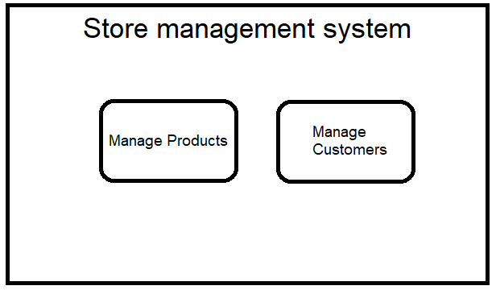

Product load screen (after typing in product ID and pressing load product):

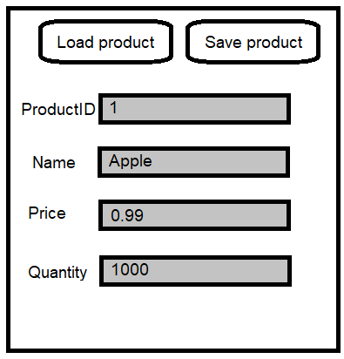

Product load screen (after changing the desired values and updating by clicking save product):

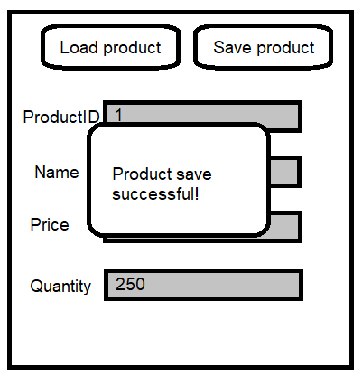

Save failure:

Default Screen:



Product load screen (after typing in product ID and pressing load product):

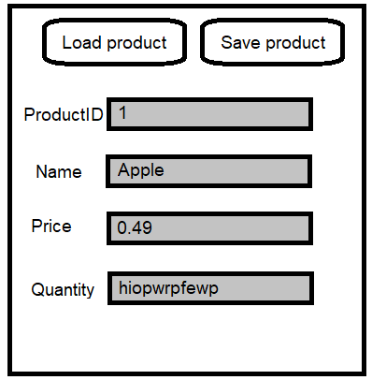

Product failure saving screen (after changing the desired values and updating by clicking save product):

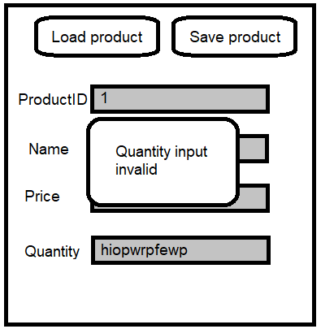

UI and use cases for “add a new customer or update a current customer into the system” for store management system (as a manager)

Default screen:



Customer load screen (after typing in customer ID and pressing load customer):

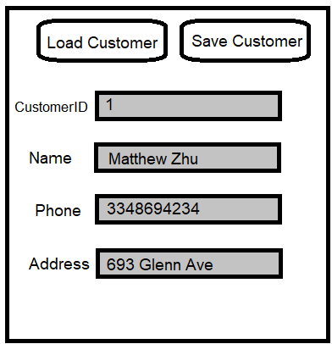

Customer load screen (after changing the desired values and updating by clicking save customer):

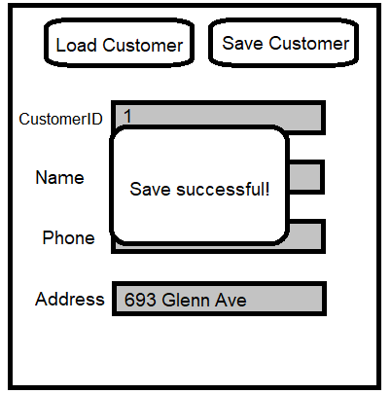

Save failure:

Default Screen:



Customer load screen (after typing in customer ID and pressing load customer):



Customer failure saving screen (after changing the desired values and updating by clicking save customer):

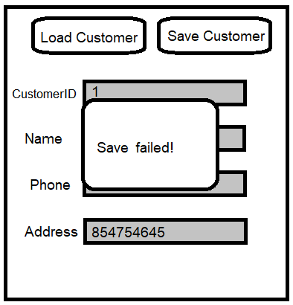

UI and use cases for “add a new purchase or update a current purchase into the system” for store management system (as a customer)

Successful purchase add:

Default screen:

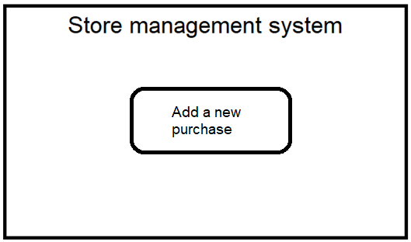

Purchase load screen (after clicking add a new purchase):

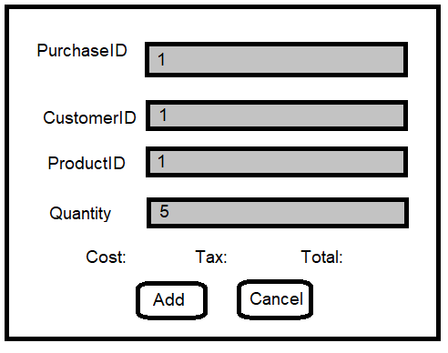

Successful Purchase load screen (after clicking add):

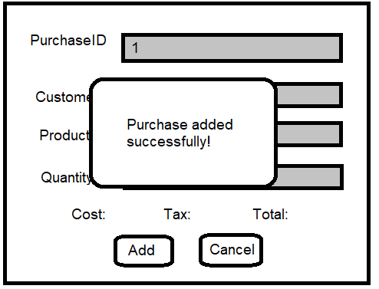

Failure adding purchase:

Default screen:



Purchase load screen (after clicking add a new purchase):



Successful Purchase load screen (after clicking add):

